University of Pittsburgh

MEMS 1042

Test Procedure

***Coefficient of Performance of a Window AC Unit***

July 2020

**Written by:**

Michael Albright

Alan Browning

Casey Cadman

William Gleeson

Mechanical Engineering and

Materials Science Department

**Goals:** To use the understanding of a refrigeration cycle to determine the steady-state coefficient of performance of a window air conditioning unit.

**Equipment Needed:**

* LG LW6019 Experimental AC System
* Multimeter
* DATAQ Model DI-2008

**Procedure:**

To calculate the coefficient of performance, we will use the LG LW6019 Experimental AC System. This system is an LG LW6019 window air conditioning unit that has had 4 sensors strategically placed in its cycle to measure the characteristics of the refrigerant. This includes 2 temperature sensors, a pressure sensor, and a flow sensor. The locations of these sensors are at the exit of the condenser and exit of the evaporator, as shown in Figure 1 below. AC systems can use a variety of refrigerants, but this system uses R410A.

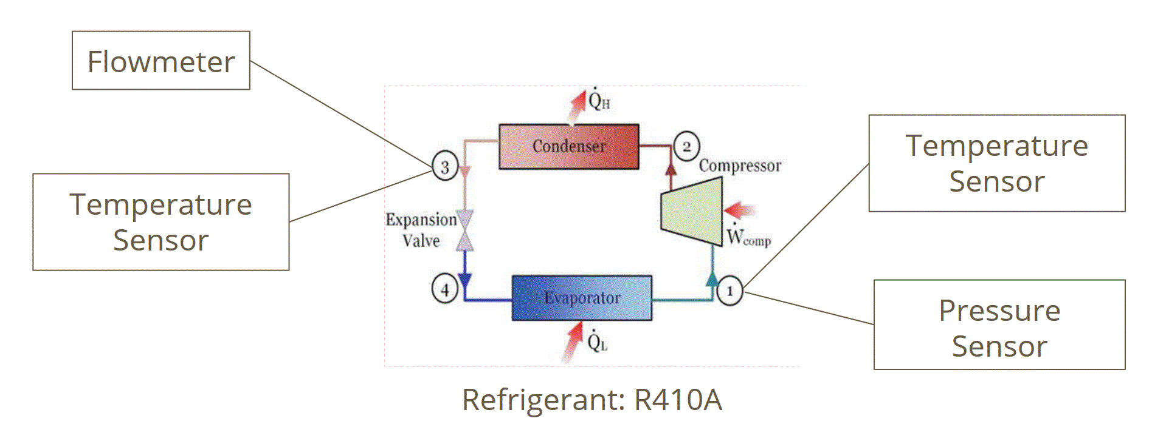

*Figure 1: Sensor locations internal to AC unit*

All of the sensors were calibrated before installation, and the sensor output relationships can be found below or by asking the lab instructor.

|  |  |
| --- | --- |
| Temperature Sensor: T(℃) = 10.271e-0.057⨉R(kΩ) | |
| Flow Sensor: 125,000 pulses per gallon | |
| Pressure Sensor: Ask Lab Instructor | |

Before the system is turned on, hook up all of the sensors to the DAQ and record these initial values to MATLAB using the premade script--provided by the lab instructor. This script will record for 15 seconds at 1 Hz . To determine the output of the flow sensor, examine the square wave plot generated by MATLAB and determine the period by looking at the time between identical points of two waves (i.e. beginning to beginning). Use this time along with the flow sensor relationship listed above to determine the flow rate. Populate Table 1 with the average readings and compare them to the expected values.

Table 1: Average Initial Values

|  |  |  |
| --- | --- | --- |
| Sensor | Average Recorded Value | Expected Value |
| State 1 Temperature Sensor |  | Room Temperature |
| State 1 Pressure Sensor |  | 220 psig |
| State 3 Temperature Reading |  | Room Temperature |
| State 3 Flow Sensor |  | 0 Gallons per Minute |

If the initial values vary dramatically from the expected values, contact the lab instructor for more information.

As the steady state coefficient of performance is the desired value, any power input fluctuations must be reduced or eliminated. To prevent this, turn the LG LW6019 Experimental AC System to the coldest possible setting and turn the fan to “High”. Let the system run for 5 minutes to allow temperatures and pressures to flatten out.

Record values again using the MATLAB script, and look at the temperature and pressure plots. If these plots display relatively constant values, populate Table 2 with the average readings. If the values are not relatively constant, wait an additional 2 minutes and then record again.

Table 2: Steady state values

|  |  |
| --- | --- |
| Sensor | Average Recorded Value |
| State 1 Pressure Reading |  |
| State 1Temperature Reading |  |
| State 3 Temperature Reading |  |
| State 3 Flow Reading |  |

Use the multimeter to measure the rms-voltage and rms-current of the electrical input of the system. A designated area has been marked at the end of the power cord where the wires can be accessed. If these values are not steady, ask the lab instructor for help, or take the average of the values seen. Record the values in Table 3 and calculate the electrical power input using Equation 1.

Table 3: Electrical input

|  |  |
| --- | --- |
| RMS-Voltage |  |
| RMS-Current |  |

|  |  |  |
| --- | --- | --- |
|  |  | (1) |

The electrical power input is _______________________ Watts.

The LG LW6019 Experimental AC System may now be turned off.

Using the average recorded temperature and pressure, determine the enthalpy of each state. Use the state properties in either the EES property calculator, or look up the value in a steam table using R410A. This experiment assumes that state 3 exists as a saturated liquid and that the expansion valve is ideal, therefore state 3 and state 4 will have the same enthalpy value. Record the state properties and the determined enthalpies in Table 4.

Table 4: State properties

|  |  |  |
| --- | --- | --- |
| State Property | State 1 | State 3 |
| Quality | Superheated Vapor | 0 |
| Temp (℃) |  |  |
| Pressure (kPa) |  | N/A |
| Enthalpy (kJ/kg) |  |  |

The next step is to determine mass flow rate. Mass flow rate is defined as the product of volumetric flow rate and density. The volumetric flow rate is recorded in Table 2 and the density can be found using the quality and temperature for State 3 in Table 4. Simply multiply these values and record the result below.

Mass Flow rate is _______________________kg/s.

Using this mass flowrate and the enthalpy difference, determine the heat flow into the evaporator, $Q_{L}$. The equation can be seen below. In this situation, State 1 is considered “out” and State 3 is considered “in.”

|  |  |  |
| --- | --- | --- |
|  | $Q_{L}=ṁ{(h_{1}-h_{4})}_{}$ | (2) |

$Q_{L}$ is __________________kJ/s.

With the heat flow into the evaporator and the electrical power into the system, calculate the coefficient of performance (𝛽), EER, and SEER values using the approximate equations below, and record the values in Table 5.

|  |  |  |
| --- | --- | --- |
|  | 𝛽 $=\frac{Q_{L}}{W}$ | (3) |

|  |  |  |
| --- | --- | --- |
|  | 𝛽 | (4) |
|  | $SEER ≅ 1.14×EER$ | (5) |

Table 5: Efficiency Values of the System

|  |  |
| --- | --- |
| Efficiency Type | Value |
| Coefficient of Performance |  |
| EER |  |
| SEER |  |

These efficiency values can be compared those from the specification sheet of this particular air conditioning unit along with those of other air conditioning units.